**TITLE OF MASTER THESIS :**

ConveyorTtracking with cobots integrated with Vision cameras

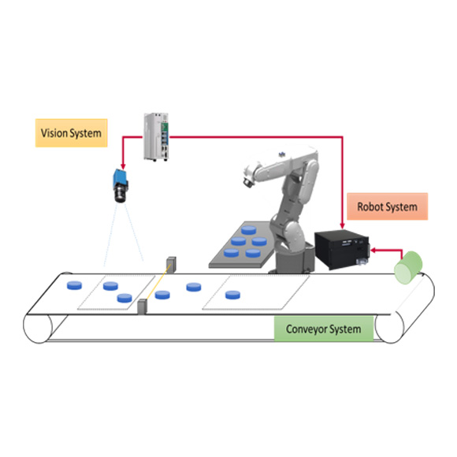

**BACKGROUND :**

This system enables cobots to dynamically interact with moving objects on a conveyor belt, improving efficiency, precision, and flexibility. By using vision cameras, cobots can accurately identify, locate, and track products in real time, regardless of variations in speed, orientation, or shape.

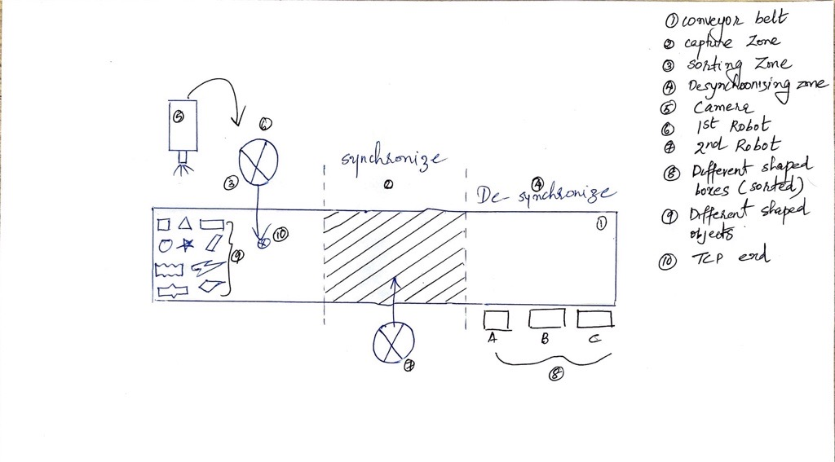

HOW IT WORKS (THESIS IDEA):

The idea of the project is to allow the cobots to learn the positon of the tool automatically and to approach them without collision, with help of an Vision camera and environmental model. Additionally, the topic discusses the challenges in synchronizing cobot actions with fast-moving conveyors and the potential benefits for industries like logistics, packaging, and electronics assembly.

The tracking setup comprises two cobots, a conveyor belt, 2 Grippers, different-shaped objects, and a Vision Camera. Once the Conveyor belt moves the differently oriented shaped objects moves across the belt and the camera captures different pose picture of the objects and its PCS (part coordinate of the system), this information is then sent to the 1st robot that helps in Sorting out different shaped objects.

Moreover, the conveyor belt consists of a capture zone where the 2nd robot syncs with the sorted object thereby picking up the object and placing it in the required target position (different-shaped boxes) provided by the user. Ultimately once the Boxes are filled up with items the boxes are removed by conveyor track or any other moving means.

In this experiment the first robot importance is basically used for sorting out the different shaped objects that are coming through conveyor belt and it thereby helps the second robot to pick and place the specified objects to defined location.

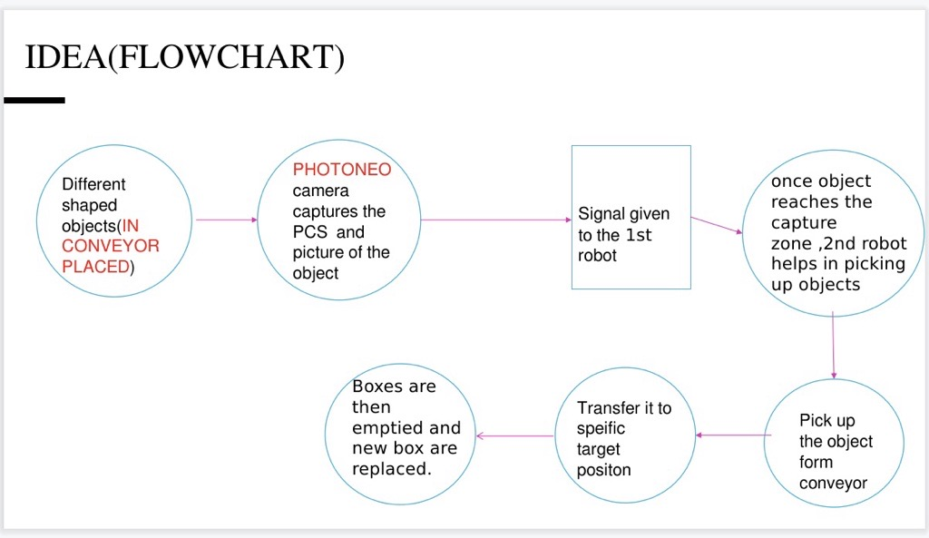

**SCIENTIFIC QUESTIONS:**

1. How can speed of conveyor belt can be adjusted the with speed of the robot in real-time
2. How much accuracy can be attained while using the Vision Camera.
3. How much time does it takes for the robot to pick up the object.

**METHODOLOGY:**

**System development:**

1. Creation and integration of a semantic prototype.
2. Integration of an algorithm for collision-free approach.
3. Integration of a tool management system for tracking relevant tool data.

**EXPECTED RESULTS:**

1. Improvement in Latency of sensor data
2. Variation in conveyor speed can be tolerated by the robot in real time.
3. Improved efficiency in tracking and picking up different sized object

**SCHEDULE (6 MONTHS):**

Month 1: Literature research and requirement definition

Month 2-3: System development and prototype implementation

Month 4-5: Conduct of the user study and data collection

Month 6: data analysis, documentation and completion